**Technical and Economic Evaluation of a New 100,000-Metric-Tons-per-Year Facility for the Production of Phthalic Anhydride from Ortho-Xylene**

**William Lee, Lucas Prescott, Jennifer Silva, and Lily Zhong**

**1. Executive Summary** **2**

1.1. Project Objectives and Proposed Technology 2

1.2. Benefits and Advantages 2

1.3. Main Findings and Conclusions 2

**2. Proposal Basis** **2**

2.1. Feedstocks and Product Grades 3

2.2. Processing Options 3

**3. Proposed Technology** **4**

3.1. Process Description 4

3.2. OSHA 1910.119 Compliance 4

3.3. Key Equipment 5

3.3.1. Plug Flow Reactor 5

3.3.2. Switch Condenser 5

3.3.3. Flash Separator 5

3.3.4. First Distillation Column 6

3.3.5. Second Distillation Column 6

3.4. Process Simulation 6

**4. Economic Assessment** **8**

4.1. Estimate of Capital Costs 8

4.2. Estimate of Production Costs 10

4.3. Estimate of Revenues, Costs, and Profits 12

4.4. Economic Evaluation 12

**5. Conclusions** **12**

**6. References Cited / Bibliography Supplementary Information** **13**

**Appendices** **15**

Appendix A: Stream Tables 15

Appendix B: Material Safety Data Sheets 19

Phthalic Anhydride 19

Maleic Anhydride 19

O-Xylene 19

Appendix C: Aspen Process Economic Analyzer Equipment Mapping and Cost 20

# **1. Executive Summary**

## 1.1. Project Objectives and Proposed Technology

The goal of our project is to design and conduct an economic evaluation on a grassroots facility to produce phthalic anhydride from pure o-xylene in Aspen Plus. Our reactor feed stream is a mixture of o-xylene, air, and a recycle stream. This stream with 7.2 wt% o-xylene and negligible contamination from the recycle stream is fed into a fluidized bed reactor (FBR), modeled as a packed bed reactor (PBR) with 10% feed gas bypass, to produce a stream with 4.3 wt% o-xylene, 3.9 wt% phthalic anhydride, and 0.14 wt% maleic anhydride. This stream is then fed into a switch condenser, modeled as two flash separators, which produces a top stream of noncondensables and 4.3 wt% o-xylene and a bottom stream of 1.8 wt% o-xylene, 96.5 wt% phthalic anhydride, and 1.5 wt% maleic anhydride. The top stream is sent through another flash separator which recycles a 93.1 wt% o-xylene stream back into the first mixer. The bottom stream is fed through two distillation columns to produce a fully condensed distillate stream of >95.0 wt% maleic anhydride and liquid stream of >99.9 wt% phthalic anhydride. These product streams are finally fed into crystallizers, producing a room temperature solid product, as is commonly sold.[1]

## 1.2. Benefits and Advantages

Although in literature there are not other standardized methods to produce phthalic anhydride using o-xylene that are fundamentally different from this current process, optimizing this method would be significant to the plasticizers industry. Plasticizers are produced when an alcohol reacts with an acid such as adipic acid, phthalic anhydride, etc.[2] Phthalic anhydride is one of the more common intermediates in the plasticizers industry, and due to high reaction rates and exothermicity, there are significant limitations when designing the process.[3] One of the main limitations is the “hot spot.” The high temperatures in the process limit the ability to thoroughly optimize the performance without completely deactivating the catalyst, and also introducing additional safety hazards. These limitations caused by the the presence of a hot spot, decrease the ability to optimize via maximizing the concentration of o-xylene in the feed gas, having optimal heat recovery, etc.[4]

## 1.3. Main Findings and Conclusions

Our Aspen simulation of a chemical plant produces 100,558 and 1,690 metric tonnes of 99.997 wt% phthalic anhydride and 95.0775 wt% maleic anhydride per year. An economic evaluation of the simulation predicts a payout period of 9.55 years, with a net present value (NPV) of $4,727,550 after 10 years. Finally, our proposal generates a total annual profit of $27,636,000 taking into account raw materials and operating costs.

# **2. Proposal Basis**

Our preliminary process design for a 100,000 metric tonnes per year of phthalic anhydride production facility will use pure o-xylene as a feed source. The feed of pure o-xylene will be provided at 100°C and 1.1 bar. O-xylene is a colorless watery liquid that is highly flammable. When exposed to oxygen, the reaction may be particularly intense, violent, or explosive at ambient temperatures. O-xylene also produces vapors that can cause headaches and dizziness. This reactant poses a particular quality issue in the way it is stored, handled, and transported through the plant. O-xylene should be stored in air sealed containers in a dry and well-ventilated place. Non-combustible absorbent mediums, such as sand or paper, can be used to take up the chemical in event of a spill and stored in containers for disposal. In event of a large spill, an evacuation protocol will be implemented for employees to remain at least 1000 ft of the spill/plant. Operators handling the o-xylene will wear PPE to avoid skin contact and accidental inhalation.[5]

There will be two product streams, phthalic anhydride and maleic anhydride. Phthalic anhydride will be produced at 99.9 wt% purity and maleic anhydride will be produced at 95.0 wt% purity. Both products’ specifications are as follows:[6][7]

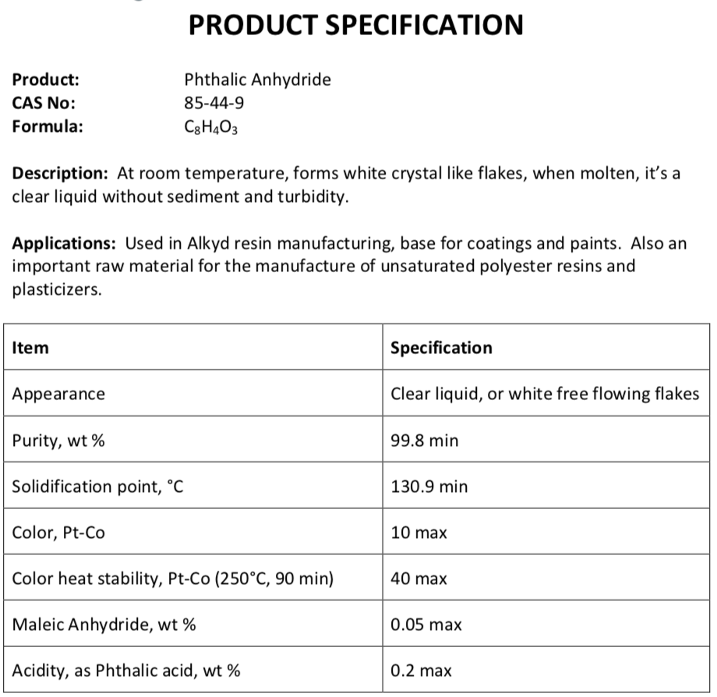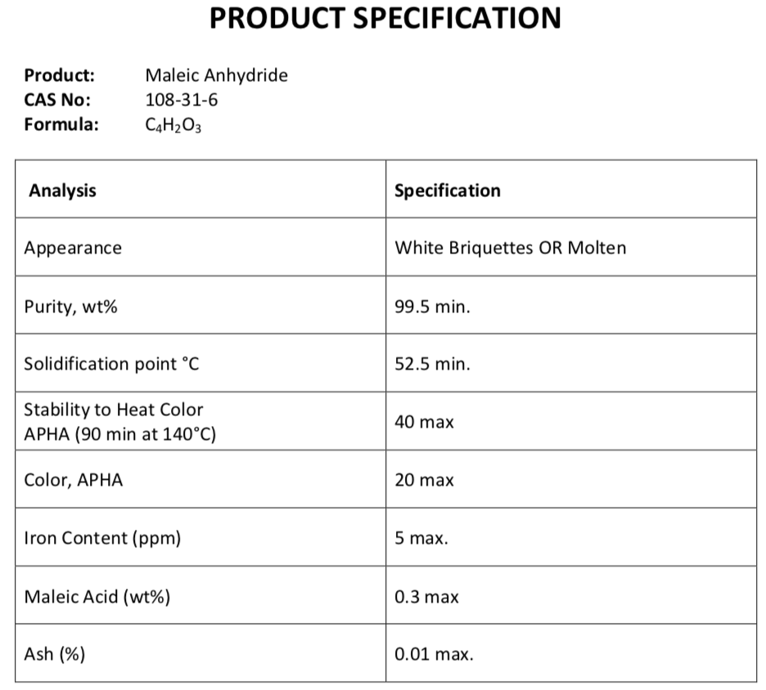

*Figures 2.1 and 2.2. Product specifications for phthalic anhydride and maleic anhydride*

## 2.1. Feedstocks and Product Grades

Our purchased and sold materials will be in accordance with American Society for Testing and Materials (ASTM) standards.[8][9][10]

## 2.2. Processing Options

This process design uses a fluidized bed reactor modeled as an isothermal plug flow reactor with 10% feed gas bypass. The reactor is set to operate at 400°C and 3 bar for maximum conversion. Alternatively, we considered using a shell-and-tube type packed-bed reactor, modeled as a plug flow reactor. However, in this design, the tubes containing catalyst would not allow sufficient heat removal resulting in hot spots and eventually catalyst damage.

# **3. Proposed Technology**

## 3.1. Process Description

Figure 3.1 shows the proposed process flow diagram for the chemical plant. Pure o-xylene and air will first be mixed and compressed before being fed into a fluidized bed reactor, modeled in Aspen Plus as an isothermal plug flow reactor with 10% bypass. The crude product stream will be initially processed with a switch condenser, modeled as two flash separators. The bottoms of these first two separators are mixed and sent to the distillation columns. A third separator is used to separate the noncondensable gases (nitrogen, oxygen, carbon dioxide) and water vapor from the unreacted o-xylene, which is fed back into the reactor as a reheated recycle stream. In the first, smaller distillation, the phthalic anhydride and maleic anhydride are purified into the bottom stream. Top waste (mainly water vapor and o-xylene) generated from this distillation is combined with the air from the third flash separator and sent to be treated. The bottom liquids of the first distillation column is fed into a second distillation column, where the maleic anhydride is separated from the phthalic anhydride. This simulation generates 100,558 and 1,690 metric tonnes per year of 99.997 wt% phthalic anhydride and 95.0775 wt% maleic anhydride, respectively.

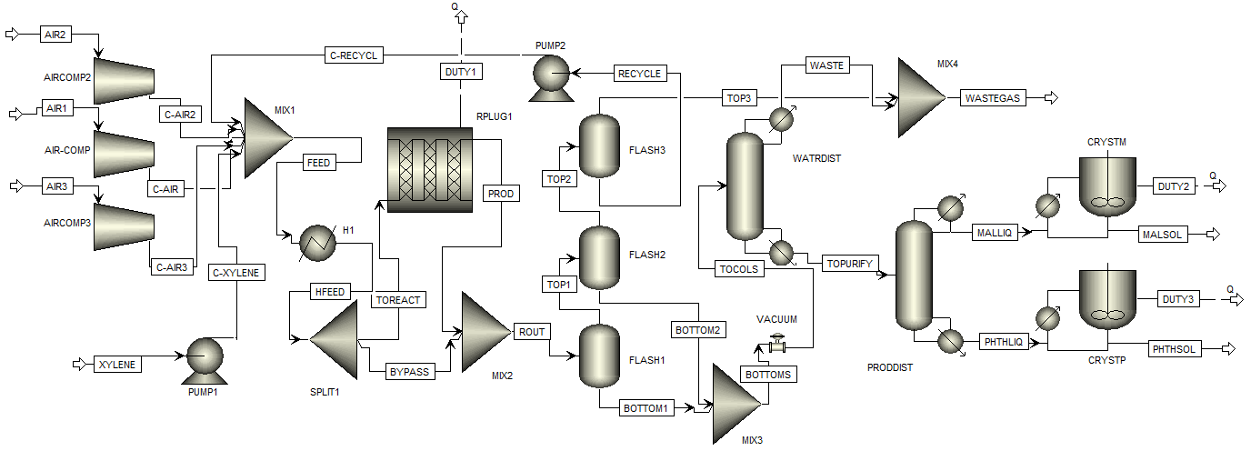

*Figure 3.1. Process Flow Diagram for Proposal*

## 3.2. OSHA 1910.119 Compliance

Due to the nature of the process and plant, OSHA 1910.119 regulations need to be complied with. There is inherently a risk for accidental release that could be hazardous even if the release were to be controlled. An accidental release risks reaching a disastrous level if it is not easily controlled with the plants current safety management and plan.[11] Proper management of change procedures will be followed at the plant, in compliance with OSHA regulations. Based on prior safety incidents with the chemicals in this process and Material Safety Data Sheets describing the explosive nature of the components in this process, these chemicals do indeed pose a threat to workers and the community when mismanaged.[12] Multiple instances of explosions leading to releases of phthalic anhydride were investigated and said to have been caused by lack of training in basic chemical knowledge of incompatible chemicals and proper storage conditions.[13] Learning from these past instances my complying with OSHA regulations will prevent similar instances from occurring at the designed plant.

## 3.3. Key Equipment

### 3.3.1. Plug Flow Reactor

The plug flow reactor has a diameter of 2 meters and a length of 5 meters, resulting in a volume of 15.7 m3. The reactor operators at a temperature of 400°C and a pressure of 3 bar. These values were chosen to maximize the conversion while staying within the constraints of our system. The catalyst has a particle density of 1600 kg/m3 and a bed voidage of 0.5. O-xylene is also flammable in air between 1 mol% and 6 mol%, and our catalyst is only sufficiently selective when o-xylene is less than 10 mol%. Sensitivity analysis determined that operating as close to 1% as possible achieved maximum conversion. Although only 40.3% of o-xylene reacts per pass, the very pure recycle stream prevents most o-xylene from being wasted while also allowing a smaller reactor. Of this 40.3%, 96.8% becomes phthalic anhydride, 2.2% becomes maleic anhydride, and 1.0% is fully combusted into carbon dioxide.

### 3.3.2. Switch Condenser

Because the phthalic anhydride partial pressure in the reactor outlet stream is so low, is desublimates rather than condenses. In the plant this would be a set of three condensers that cycle between cooling with low-temperature oil to desublimate, loading solids onto a heat transfer surface, stopping gas flow, and reheating with hot oil to melt the solid. Three condensers (in alternating desublimating, melting, and standby modes) would be used to keep the two stream (liquid condensables and vapor noncondensables with some maleic and phthalic anhydride) as continuous as possible. To prevent overcomplicating this unit operation in Aspen Plus simulations, we modeled it as two flash separators with mixed bottoms. These separators were modeled to operate at 110°C and 80°C and 2 bar (90,073 L, 18 foot diameter and 85,138 L, 17.5 foot diameter), respectively. The bottoms stream to be fed to the columns would operate at 86.9 kmol/hr and would recover 99.4 mol% phthalic anhydride, 41.8 mol% maleic anhydride, and only 1.7% o-xylene and 0.6% water from the crude reactor product feed stream. Its would contain 96.5 wt% phthalic anhydride, 1.4 wt% maleic anhydride, 1.7 wt% o-xylene, and 0.2 wt% water. The vapor stream would have a flow rate of 10,056 kmol/hr or 296.517 tonnes/hr and would contain 1.25 mol% organics.

### 3.3.3. Flash Separator

A flash separator operating at 10°C and 2 bar (95,146 L, 18.5 foot diameter) was added after the switch condenser to prevent wasting unreacted o-xylene and excessive dirty air stream treatment. The feed containing 1.25 mol% organics would be separated such that the waste gas stream to be treated would only contain 0.16 mol% organics and the liquid stream would contain 93.1 wt% o-xylene recycling at 108.48 kmol/hr (total stream 140.99 kmol/hr). Further optimization could reduce the cooling and reheating required for this unit operation, but the waste cost reduction and recycled o-xylene should outweigh these operating costs.

### 3.3.4. First Distillation Column

The first distillation column has a total of 10 stages, 2 feet tray spacing, 1.5 feet diameter, and a pressure of 0.3 bar. A low pressure is used to improve the degree of separation while keeping the number of stages as low as possible. The feed is input on stage 2 and the output streams are the purified products stream and the waste stream. From an 86.8 kmol/hr feed (1.7 wt% o-xylene, 96.5 wt% phthalic anhydride, 1.5 wt% maleic anhydride, 0.2 wt% water), the operating specifications were set to a distillate rate of 3.7 kmol/hr and a reflux ratio of 1, resulting in a bottom operating temperature of 234.5°C and flow rate of 83.2 kmol/hr (98.5 wt% phthalic anhydride, 1.5 wt% maleic anhydride, negligible o-xylene and water). The condenser stream is left as a vapor to allow for proper waste disposal and a kettle reboiler is used for the bottoms stream.

### 3.3.5. Second Distillation Column

The second distillation column is much larger due to the relatively close boiling points of the phthalic anhydride and maleic anhydride desired products. There are a total of 29 stages spaced 2 feet apart and 3.5 feet in diameter operating at 0.3 bar. The operating specifications are a bottom flow rate of 81.3 kmol/hr of 99.997 wt% phthalic anhydride and a reflux ratio of 7, resulting in a top flow rate of 1.94 kmol/hr of maleic anhydride at 95.0786 wt%. A high reflux ratio is used to increase the purity of the output streams as much as possible. The feed is on stage 6 to maximize the degree of chemical separation. A total condenser is also used to deliver both product streams as a liquid. A kettle reboiler is used for the bottom stream and the outlet temperatures of the product streams are 160°C for the maleic anhydride and 240°C for the phthalic anhydride.

## 3.4. Process Simulation

Our simulation uses the Soave-Redlich-Kwong (SRK) thermodynamic model, with a free-water method of STEAMNBS. The SRK model was chosen due to its accuracy in describing vapor–liquid equilibria and the free water method was chosen to reconcile the Aspen Plus stream and process calculations.[1] We believe that the combination of the previously mentioned thermodynamic models best describe the behavior of the components at their specified temperatures and pressures.

Some key simplifications that we made in our simulation are for the switch condenser and the fluidized bed reactor. The switch condenser cannot be accurately modeled in Aspen Plus due to its complicated design and batch nature, so it was substituted with a series of flash condensers that operate at different temperatures and pressures likely similar to those of the switch condenser. With this method, the actual degree of separation can be accurately estimated without having to model the switch condenser. The fluidized bed reactor was modeled as an isothermal plug flow reactor with a 10% bypass to simplify the preliminary calculations while obtaining an accurate operating specifications and parameters such as reactor volume, temperature, pressure, and conversion.

The reaction itself was modeled as a combination of five irreversible reactions shown below:[1]

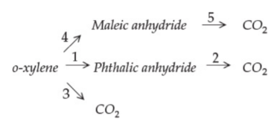

*Figure 3.2. Simplified five irreversible reactions outlined in process details*

The reaction kinetics were modeled using the following stoichiometric coefficients:

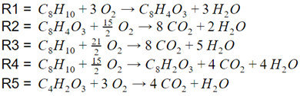

*Figures 3.3. Stoichiometric ratios based on five irreversible reactions*

The rate expression was calculated using the power law, literature activation energies, and reference temperature values as shown below:

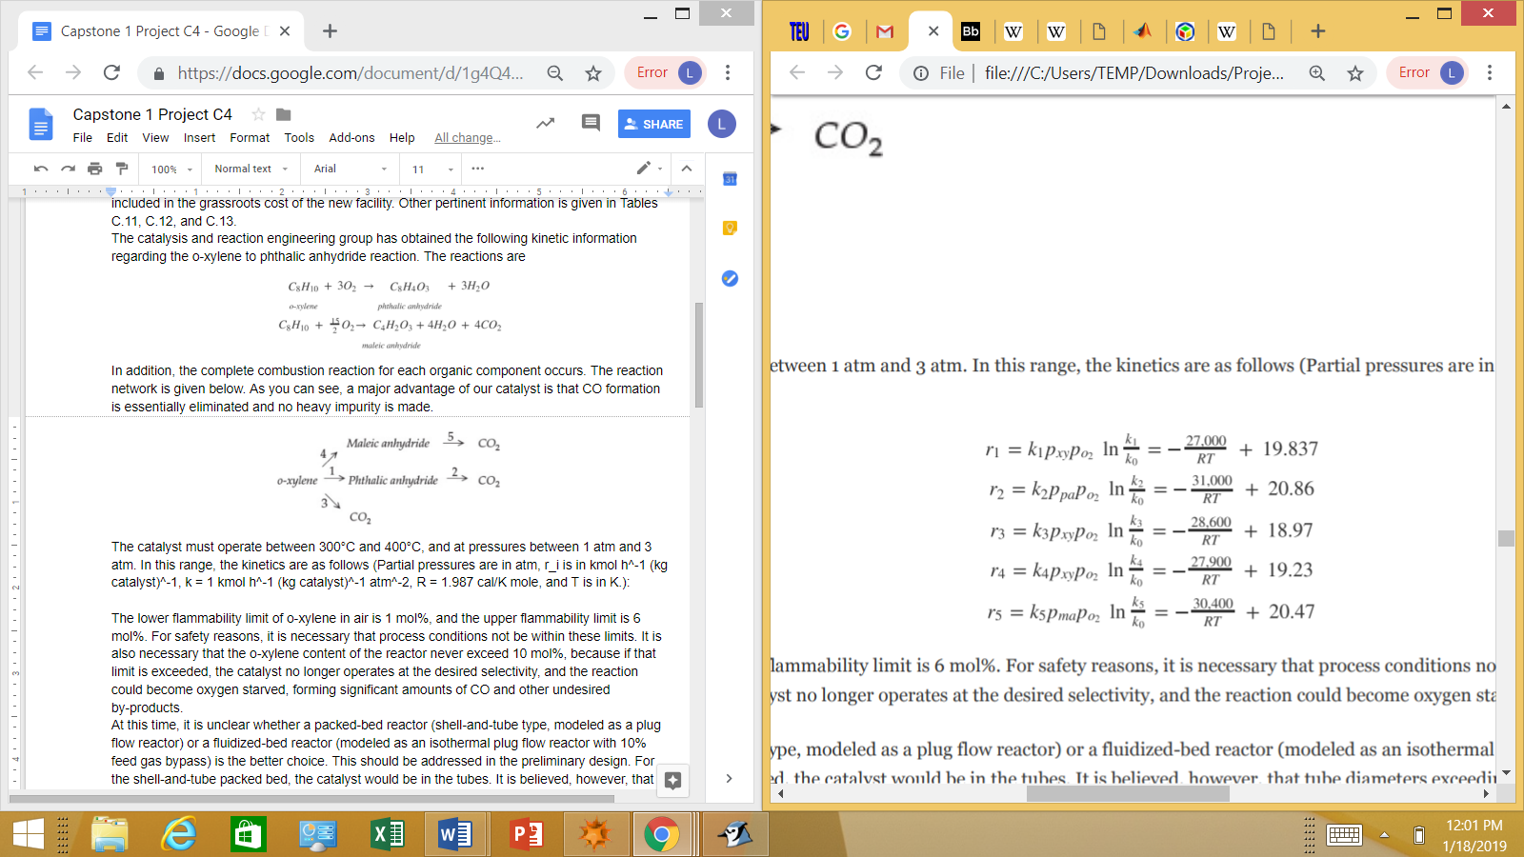 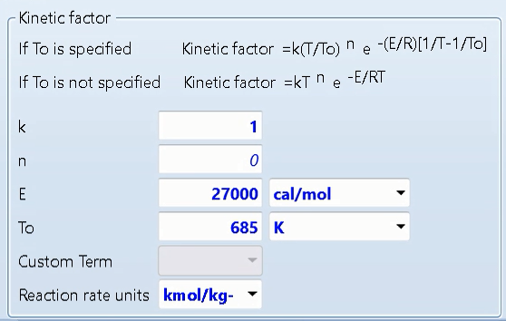

*Figure 3.4. Figure 3.5.*

*Rate expression calculations Kinetic factors used to calculate rate expressions*

Finally, the flow rates and compositions of raw materials, products and waste streams are shown below:

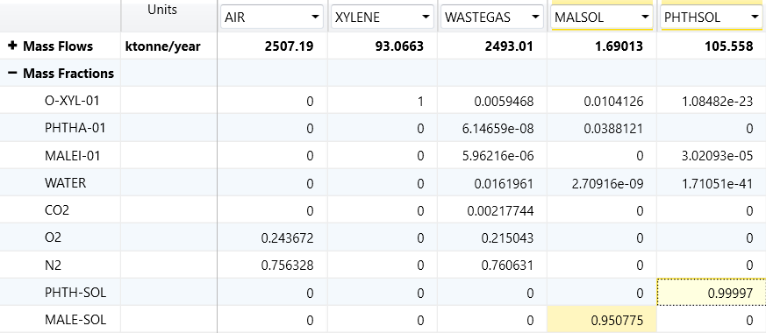

*Figure 3.6. Overall Aspen raw materials and products composition*

A feed of 9900 kmol/hr air composed of 22 mol% oxygen and 78 mol% nitrogen at 100°C and 1.1 bar is mixed with a 100 kmol/hr feed of pure o-xylene at 100 °C and 1.1 bar. From these feeds, two product streams and one gaseous waste stream is generated. The phthalic anhydride product is generated with 99.997 wt% purity at a rate of 81.3 kmol/hr, which corresponds to 105,558 metric tonnes per operating year. The maleic anhydride product is generated in a side reaction at a purity of 95.0786 wt% at a rate of 1.94 kmol/hr, or 1,690 tonnes per year. Finally the waste stream, which is mainly composed of air, water, o-xylene, and carbon dioxide, is generated at a rate of 9918.93 kmol/hr, or 2,493,010 tonnes per year. Although the mass of the waste stream is large, the mole fraction of organics is very small, significantly reducing the treatment cost.

**4. Economic Assessment**

## 4.1. Estimate of Capital Costs

The Aspen Process Economic Analyzer simulation estimates a total project capital cost of $44,519,700. Table 4.1 shows the equipment component list of these capital costs:

Table 4.1: Equipment Cost and Weight List

|  |  |  |  |  |
| --- | --- | --- | --- | --- |
| Equipment Name | Total Direct Cost [USD] | Equipment Cost [USD] | Equipment Weight [lbs] | Installed Weight [lbs] |
| 3x air compressors | 4,779,700 each | 4,254,600 each | 181,000 each | 238,248 each |
| O-xylene pump | 20,300 | 4,300 | 110 | 1,119 |
| Recycle pump | 17,800 | 4,200 | 110 | 751 |
| Mixer 1 | 170,600 | 77,300 | 2,500 | 8,784 |
| Heater | 80,000 | 17,000 | 1,800 | 6,636 |
| FBR | 716,400 | 178,800 | 16,100 | 54,695 |
| Splitter 1 | 192,200 | 43,500 | 7,000 | 22,273 |
| PFR | 316,100 | 64,000 | 6,800 | 23,420 |
| Mixer 2 | 208,100 | 71,300 | 2,300 | 9,002 |
| Switch condensers | 1,048,400 | 379,600 | 46,000 | 97,148 |
| Flash 1 | 539,400 | 166,900 | 24,200 | 49,841 |
| Flash 2 | 362,100 | 150,300 | 19,900 | 40,429 |
| Mixer 3 | 146,900 | 62,400 | 1,900 | 6,878 |
| Flash 3 | 378,100 | 163,700 | 22,500 | 42,597 |
| Vacuum | 40,500 | 14,300 | 330 | 1,296 |
| Distillation column 1 | 385,500 | 91,300 | 6,830 | 22,212 |
| Condenser | 44,600 | 8,900 | 230 | 1,494 |
| Condenser accumulator | 88,100 | 17,800 | 1,500 | 5,295 |
| Reboiler | 89,600 | 29,300 | 3,000 | 6,411 |
| Reflux pump | 17,000 | 4,600 | 100 | 719 |
| Tower | 146,200 | 30,700 | 2,000 | 8,293 |
| Mixer 4 | 158,400 | 71,300 | 2,300 | 7,600 |
| Distillation column 2 | 631,600 | 228,300 | 22,210 | 51,250 |
| Condenser | 93,000 | 19,100 | 2,200 | 9,224 |
| Condenser accumulator | 90,100 | 17,800 | 1,500 | 5,810 |
| Reboiler | 75,900 | 25,500 | 2,400 | 4,783 |
| Reflux pump | 18,700 | 4,600 | 110 | 928 |
| Tower | 353,900 | 161,300 | 16,000 | 30,505 |
| Phthalic anhydride crystallizer | 1649800 | 1258000 | 0* | 7053 |
| Maleic anhydride crystallizer | 140,700 | 82,900 | 0* | 930 |
| Total | 19,777,200 | 15,334,800 | 663,790 | 1,016,815 |

*Cost calculated using crystallization rate

## 4.2. Estimate of Production Costs

Variable costs of production include raw materials, utilities, consumables, and effluent disposal costs. The raw material cost of o-xylene used in the feed was found to be $1.40/kg.[14] The waste gas stream treatment cost was calculated to be $0.000157/kg or $1.57/tonne from the mass flow rate of the waste stream and the following formula: Cost = $10-4Vtot(0.5 + 1000*xor*),[15] where Vtot is volume in cubic meters and *xor* is the mole fraction of organics. Inputting all these values into Aspen Process Economic Analyzer results in a raw materials cost of $118,905,000/year and a utilities cost of $171,802/year.

Fixed costs of production include operating labor, supervision, plant overhead, and maintenance costs. Operating labor costs, the money that is paid to the plant’s employees, is estimated to be $1,080,000/year. Costs associated with operator supervision is estimated to be $280,000/year. The forecasted price of plant maintenance is $360,000/year and the estimated price of plant supervision is $280,000/year.

Table 4.2 Estimates of Variable Costs of Production

|  |  |
| --- | --- |
| Cost Description | Estimated Cost |
| Raw materials | $118,905,000.00 |
| Total Utilities Cost | $171,802.00 |
| Effluent disposal (waste stream costs in products) | $-446.49/hr |

Table 4.3 Estimates of Fixed Costs of Production

|  |  |
| --- | --- |
| Cost Description | Estimated Cost |
| Operating labor | $1,080,000.00 |
| Supervision (add) | $280,000.00/year |
| Plant overhead | $720,000.00/year |
| Maintenance | $360,000.00 |

Table 4.4 Estimates of Costs of Utilities

|  |  |  |  |  |
| --- | --- | --- | --- | --- |
| Utility | Energy Price | Inlet Temperature (°C) | Outlet Temperature (°C) | Heat Transfer Coefficient (GJ/hr-sqm-°C) |
| Air | 0 $/kJ | 30 | 35 | 0.0003996 |
| Electric | 0.0775 $/kWhr | N/A | N/A | N/A |
| Low pressure steam | 1.89e-6 $/kJ | 125 | 124 | 0.0216 |
| Medium pressure steam | 2.2e-6 $/kJ | 175 | 174 | 0.0216 |
| High pressure steam | 2.5e-6 $/kJ | 250 | 249 | 0.0216 |
| Cooling water | 2.12e-7 $/kJ | 20 | 25 | 0.0135 |
| Refrigerant 1 | 2.74e-6 $/kJ | -25 | -24 | 0.00468 |
| Hot oil | 3.5e-6 $/kJ | 70 | 100 | 0.000836215 |
| Cold oil | 3.5e-6 $/kJ | 40 | 70 | 0.000836215 |

Table 4.5 Estimates of Equipment Utilities Duty and Cost

|  |  |  |  |
| --- | --- | --- | --- |
| Equipment Name | Duty | Utility | Utility Cost [USD/hr] |
| 3x air compressor | 11,182 kW total* | Electric | 866.61 total* |
| O-xylene pump | 2.22 kW | Electric | 0.17 |
| Recycle pump | 1.11 kW | Electric | 0.09 |
| Heater | 724369 kJ/hr | Hot Oil | 2.54 |
| FBR | -94,288,997 kJ/hr* | GHP steam | -235.72* |
| Switch condensers |  | Oil | 401.98* |
| Flash 1 | -105,021,379 kJ/hr* | Hot oil | 367.57* |
| Flash 2 | -9,754,696 kJ/hr* | Cold oil | 34.14* |
| Flash 3 | -27,574,736 kJ/hr* | Refrigerant 1 | 75.55* |
| Distillation column 1 |  |  | 7.23 |
| Condenser | -188,901 kJ/hr | Cooling water | 0.04 |
| Reboiler | 2,872,288 kJ/hr | HP steam | 7.18 |
| Reflux pump | 0.19 kW | Electric | 0.01 |
| Distillation column 2 |  |  | 0.81 |
| Condenser | -912,645 kJ/hr | GLP steam | -1.72 |
| Reboiler | 997,243 kJ/mol | HP steam | 2.49 |
| Reflux pump | 0.56 kW | Electric | 0.04 |
| Phthalic anhydride crystallizer | -4,161,711 kJ/hr* | Cooling water | 0.88* |
| Maleic anhydride crystallizer | -61,304 kJ/hr* | Cooling water | 0.01* |
| Total | -237,359,283* |  | 1127.93* |

*duty taken from aspen plus file and cost was manually calculated from utility cost/energy

## 4.3. Estimate of Revenues, Costs, and Profits

Using current product prices of $1.42/kg of maleic anhydride[16] and $1.61/kg of phthalic anhydride[17] results in total product sales of $153,713,000/year. Interestingly, correlations between sport prices of o-xylene and xylenes[18] and xylenes and Brent crude oil[19] have been found. The combined correlation, o-xylene[$/tonne] = 190.5 + 10.38*Brent crude[$/bbl], can be used to estimate o-xylene cost when data is scarce. O-xylene is, however, mainly used to produce phthalic anhydride, so their prices should be correlated. This likely nets out to a constant 0.21$/kg phthalic anhydride no matter o-xylene cost. Finally, taking into account a total operating cost of $131,227,000/year, a revenue of $65,461,300/year by year 10.

## 4.4. Economic Evaluation

The net present value (NPV) of the project after 10 years is calculated to be $4,727,550 with a payout period of 9.55 years. This means that the plant pays off all initial investments after 9.55 years and generates a total profit of $4,727,550 at the end of its 10 year life. The internal rate of return (IRR) is the discount rate at which the net present value of the project’s initial investment is equal to 0. This project’s IRR is 21.48%.

# **5. Conclusions**

With our more optimal catalyst, production of phthalic anhydride and minimal maleic anhydride at this scale would be very profitable. Our design’s extra flash separator and recycle stream distinguish it from previous phthalic anhydride production facilities because it would prevent wasting reactant o-xylene and wasting money treating dirty air. Further optimization of this flash separator could minimize stream heating and cooling and associated utility costs. Our simplified reactor and switch condenser Aspen Plus models need to also be verified to be accurate before final product flow rate and purity and profitability can be more accurately evaluated. Even with these concerns, our >99.9 wt% and >95.0 wt% phthalic and maleic anhydride streams would result in a large predicted annual profit of $27,636,000, resulting in a payout period of 9.55 years. Additional investment in plant maintenance could extend the plant’s life beyond 10 years, allowing for even more profit.

# **6. References Cited / Bibliography Supplementary Information**

[1] Bailie, Richard, et al. *Analysis, Synthesis, and Design of Chemical Processes, Fifth Edition*, 2018.

[2] Koester, Vera. “Plasticizers – Benefits, Trends, Health, and Environmental Issues.” *ChemistryViews*, 5 May 2015. www.chemistryviews.org/details/ezine/7874391/Plasticizers__Benefits_Trends_Health_and_Environmental_Issues.html.

[3] Mülheims, Philip, and Bettina Kraushaar-Czarnetzki. "Temperature profiles and process performances of sponge packings as compared to spherical catalysts in the oxidation of o-xylene to phthalic anhydride." *Industrial & Engineering Chemistry Research* 50.17 (2011): 9925-9935.

[4] Groppi, Gianpiero, et al. "Conductive monolithic catalysts: development and industrial pilot tests for the oxidation of o-xylene to phthalic anhydride." *Industrial & Engineering Chemistry Research* 51.22 (2011): 7590-7596.

[5] National Center for Biotechnology Information. PubChem Database. O-Xylene, CID=7237, https://pubchem.ncbi.nlm.nih.gov/compound/7237

[6] “Product Specification.” *TheChemCo.*, The Chemical Company, www.thechemco.com/wp-content/uploads/2012/03/Phthalic-Anhydride-Spec-TCC.pdf.

[7] “Product Specification.” *TheChemCo.*, The Chemical Company, https://www.thechemco.com/wp-content/uploads/2012/03/Maleic-Anhydride-Spec-TCC.pdf

[8] ASTM D5471-18, Standard Specification for O-Xylene 980, ASTM International, West Conshohocken, PA, 2018, www.astm.org

[9] ASTM D3504-96, Standard Specification for Maleic Anhydride, ASTM International, West Conshohocken, PA, 1996, www.astm.org

[10] ASTM D2403-96, Standard Specification for Refined Phthalic Anhydride-1308, ASTM International, West Conshohocken, PA, 1996, www.astm.org

[11] “United States Department of Labor.” *Occupational Safety and Health Administration*, 2017, www.osha.gov/SLTC/processsafetymanagement/.

[12] Arai, Mitsuru. “Case Details.” *Shippai: Failure Knowledge Database*, Association for the Study of Failure, 2009, www.shippai.org/fkd/en/cfen/CC1000122.html.

[13] Peerenboom, Greg. “Chemical Released into Air in Explosion at Ontario Plant.” *Toronto Sun*, Postmedia Network Inc., 27 Aug. 2013, torontosun.com/2013/08/27/chemical-released-into-air-in-explosion-at-ontario-plant/wcm/bd93bf0f-3f94-4001-b053-9da9bee689b7.

[14]“Orthoxylene Price History & Forecast.” *Intratec Solutions*, Intratec Solutions, LLC, 2017, www.intratec.us/chemical-markets/orthoxylene-price.

[15] Towler, Gavin, and R. K. Sinnott. Chemical Engineering Design : Principles, Practice and Economics of Plant and Process Design, Elsevier Science & Technology, 2012. ProQuest Ebook Central, https://ebookcentral.proquest.com/lib/northeastern-ebooks/detail.action?docID=858659.

[16] “Phthalic Anhydride Price History & Forecast.” *Intratec Solutions*, Intratec Solutions, LLC, 2017, https://www.intratec.us/chemical-markets/maleic-anhydride-price

[17] “Maleic Anhydride Price History & Forecast.” *Intratec Solutions*, Intratec Solutions, LLC, 2017, https://www.intratec.us/chemical-markets/maleic-anhydride-price

[18] “C6: The Price of Para and Ortho Xylene.” *Duncan Seddon & Associates Pty. Ltd.*, 2013, <http://www.duncanseddon.com/docs/pdf/c6-the-price-of-para-and-ortho-xylene.pdf>

[19] “C5: The impact of oil price on BTX price.” *Duncan Seddon & Associates Pty. Ltd.*, 2013, <http://www.duncanseddon.com/c5-the-impact-of-oil-price-on-aromatics-price/>

[19] *Phthalic Anhydride*; MSDS No. 85-44-9 [Online]; Thermo Fisher Scientific: Fair Lawn, NJ, November 19, 2008. https://www.fishersci.com/store/msds?partNumber=AC423320050&productDescription=PHTHALIC+ANHYDRIDE%2C+ACS+5KG&vendorId=VN00032119&countryCode=US&language=en

[20] *O-xylene*; MSDS No. 95-47-6 [Online]; Thermo Fisher Scientific: Fair Lawn, NJ, June 15, 2010. https://www.fishersci.com/store/msds?partNumber=O50814&productDescription=O-XYLENE+R+4L&vendorId=VN00033897&countryCode=US&language=en

[21] *Maleic Anhydride*; MSDS No. GHS 1.0 [Online]; IDESA Petroquímica: Mexico City, Mexico, June 05, 2017. http://www.idesapetroquimica.com/data/nuestros_productos/hoja_seguridad/en_producto_02/MSDS%20MA%20EN%202016.pdf.

# **Appendices**

## Appendix A: Stream Tables

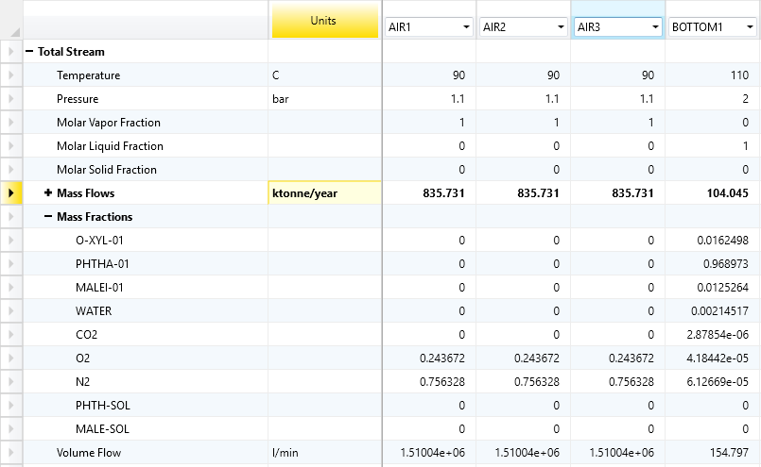

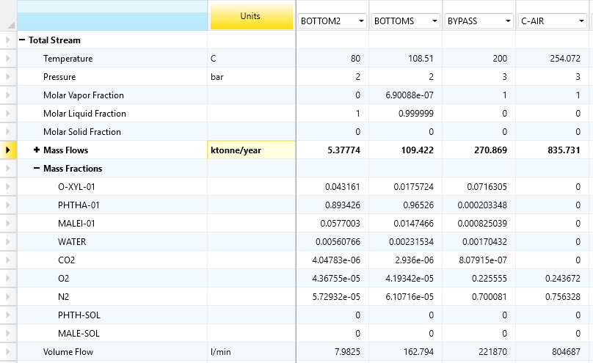

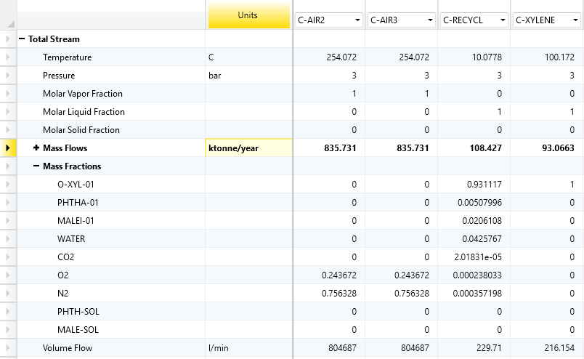

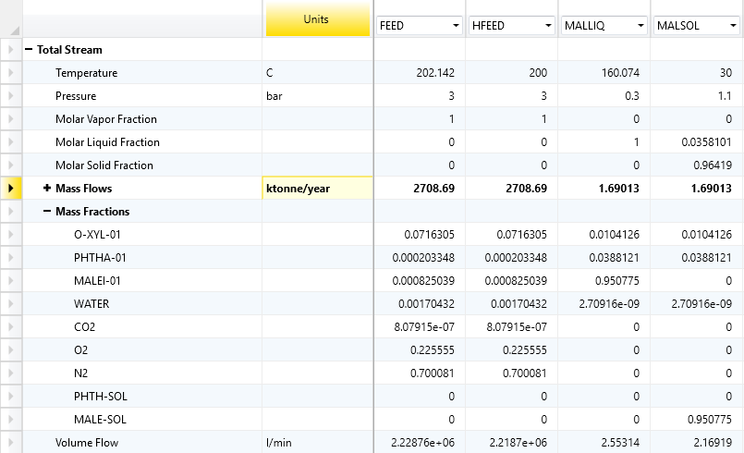

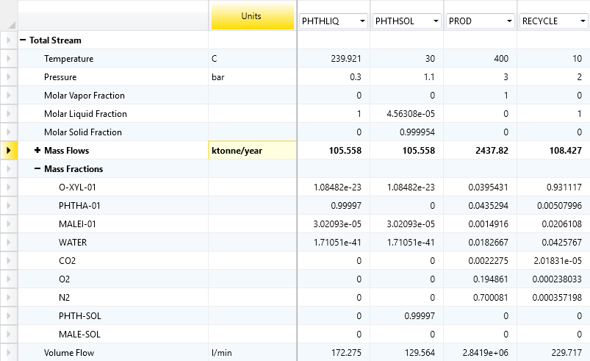

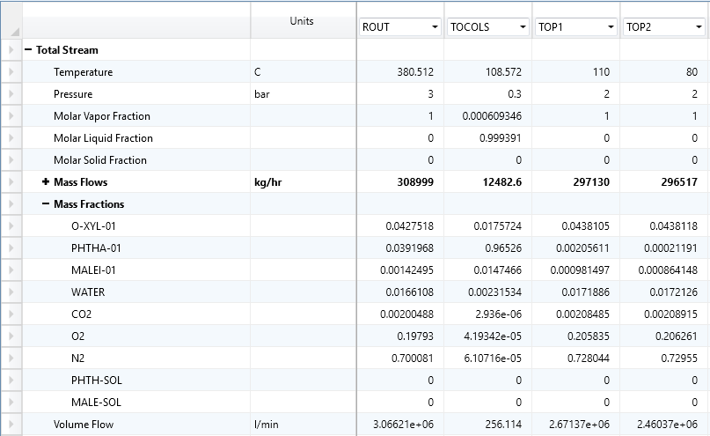

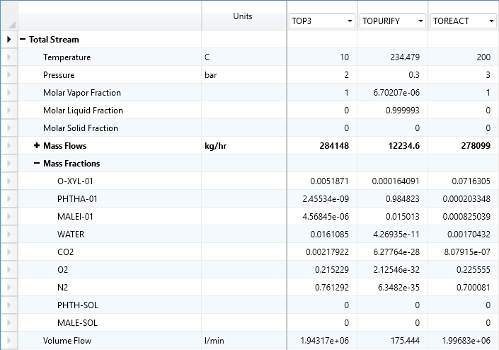

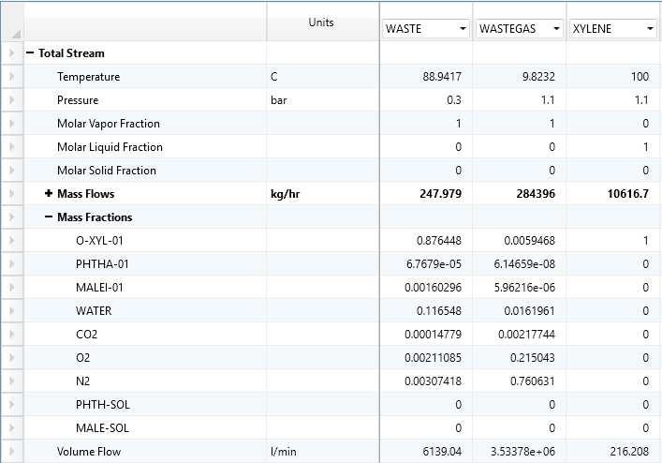

## Appendix B: Material Safety Data Sheets

### Phthalic Anhydride

https://www.fishersci.com/store/msds?partNumber=AC423320050&productDescription=PHTHALIC+ANHYDRIDE%2C+ACS+5KG&vendorId=VN00032119&countryCode=US&language=en[20]

### Maleic Anhydride

http://www.idesapetroquimica.com/data/nuestros_productos/hoja_seguridad/en_producto_02/MSDS%20MA%20EN%202016.pdf[21]

### Ortho-Xylene

https://www.fishersci.com/store/msds?partNumber=O50814&productDescription=O-XYLENE+R+4L&vendorId=VN00033897&countryCode=US&language=en[22]

## Appendix C: Aspen Process Economic Analyzer Equipment Mapping and Cost

